7. Draw a CMOS buffer schematic.
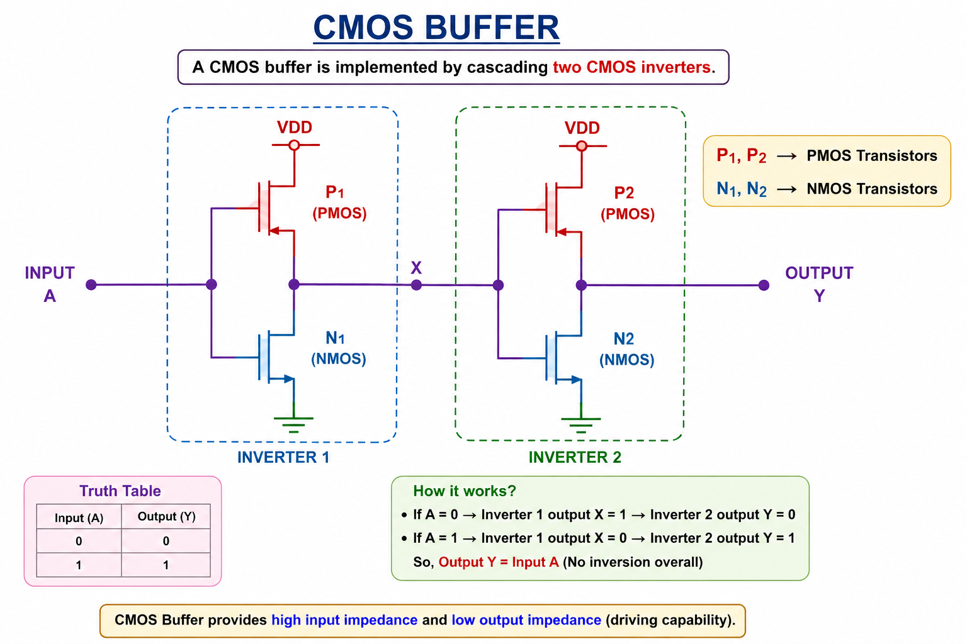

10. Draw a CMOS AND gate schematic.
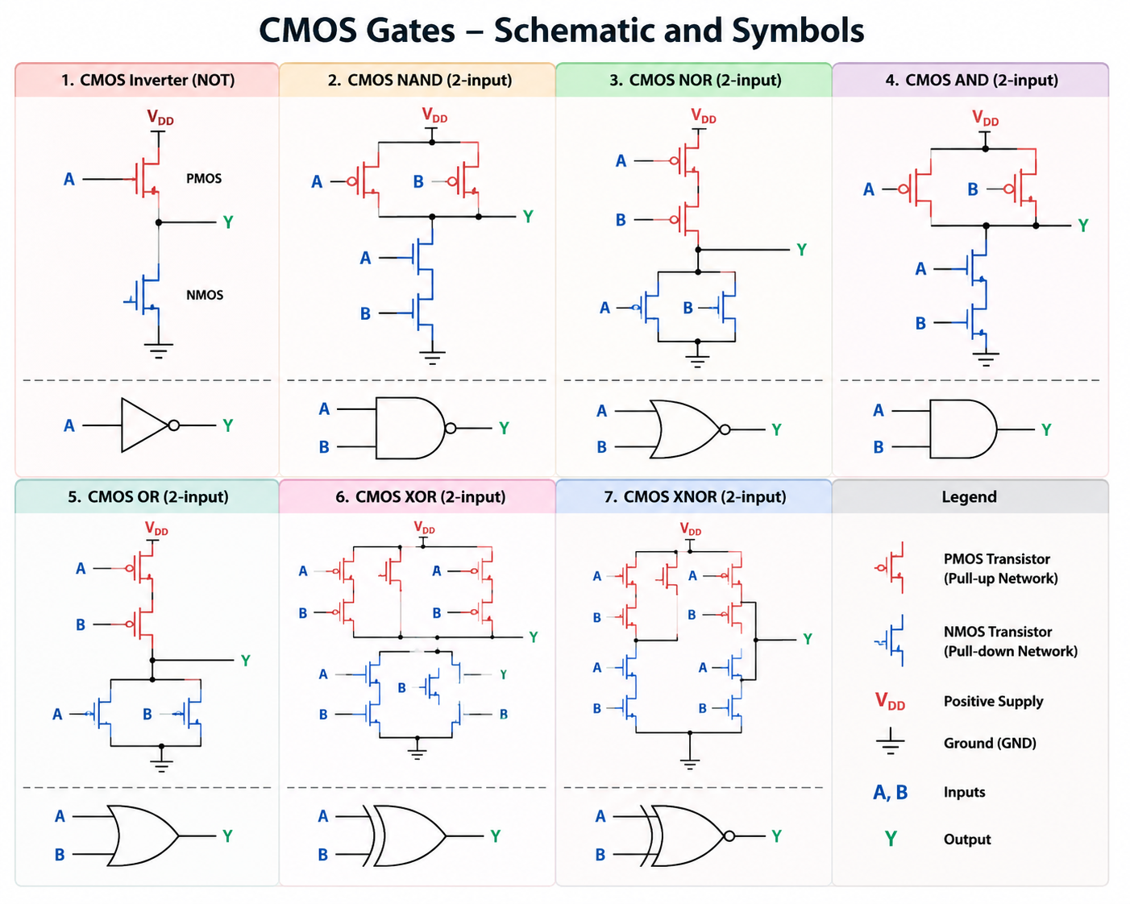

60. How does data travel from one flip-flop to another?
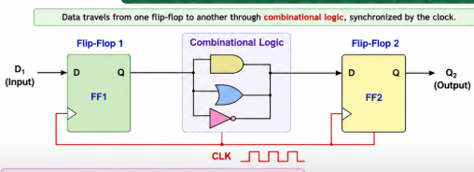

- Given a logic diagram, how do you derive the Boolean expression?


